
KCA UNIVERSITY
School of Computing and Information Technology
BACHELOR OF INFORMATION SECURITY AND FORENSICS

MACHOKA ENTERPRISE NETWORK INFRASTRUCTURE DESIGN USING CISCO PACKET TRACER

Secure Enterprise Network Implementation with VLAN Segmentation, Inter-VLAN Routing, Wireless Networking, DHCP, SSH, ACLs, Port Security, DHCP Snooping and Cisco ASA Firewall

Prepared By

Samuel Machoka Arita
Admission Number: 25/09489

Submitted To
Lecturer's Name

Course Unit
Computer Networks / Network Security

Department
School of Computing and Information Technology

KCA University
Nairobi, Kenya

Date
July 2026

Declaration
I declare that this project report is my own original work and has not been submitted to any other institution for academic credit. All sources of information have been appropriately acknowledged.
Signature: ___________________
Date: ___________________

Acknowledgement

I would like to express my sincere gratitude to my lecturer for guiding this project. I also appreciate KCA University for providing the learning environment and resources that enabled me to complete this enterprise network implementation successfully.

Abstract
This project presents the design and implementation of a secure enterprise network infrastructure using Cisco Packet Tracer. The network was developed to simulate a real-world organizational environment consisting of multiple departments including Administration, Finance, Information Technology, Server Infrastructure, Staff Wireless Network, and Guest Wireless Network.
The implementation incorporates enterprise networking technologies such as Virtual Local Area Networks (VLANs), inter-VLAN routing using a Layer 3 switch, Dynamic Host Configuration Protocol (DHCP), Secure Shell (SSH) for secure remote management, Access Control Lists (ACLs), Port Security, DHCP Snooping, and Cisco ASA firewall configuration. Wireless users were segmented into Staff and Guest networks to improve security and network management.
The completed solution demonstrates how modern enterprise networks can improve performance, scalability, and security through logical segmentation and layered security controls.

Table of Contents
MACHOKA ENTERPRISE NETWORK INFRASTRUCTURE DESIGN USING CISCO PACKET TRACER 1
Prepared By 1
Samuel Machoka Arita 1
Declaration 3
Acknowledgement 4
Abstract 5
List of tables 9
List of Abbreviations 10
CHAPTER ONE 11
INTRODUCTION 11
1.1 Background 11
1.2 Problem Statement 11
1.3 Objectives 12
1.4 Scope 13
CHAPTER TWO 14
2.0 PROJECT REQUIREMENTS 14
2.1 Enterprise Network Departments 14
2.2 Hardware Requirements 14
2.4 Software Requirements 15
2.5 Functional Requirements 15
2.6 Non-Functional Requirements 15
2.7 Chapter Summary 16
CHAPTER THREE 17
3.0 NETWORK DESIGN 17
3.1 Introduction 17
3.2 Network Topology 17
3.3 VLAN Design 18
3.4 IP Addressing Scheme 18
3.5 Network Security Design 18
3.6 Network Implementation 19
3.7 Testing and Verification 19
3.8 Chapter Summary 19
CHAPTER FOUR 20
4.0 IMPLEMENTATION, CONFIGURATION AND TESTING 20
4.1 VLAN Configuration 20
4.2 Trunk Configuration 20
4.3 Inter-VLAN Routing 21
4.4 DHCP Configuration 22
4.5 Wireless Configuration 24
4.7 Access Control Lists (ACLs) 27
4.8 Port Security 27
4.9 DHCP Snooping 28
4.10 Cisco ASA Firewall 30
CHAPTER FIVE 31
5.0 CONCLUSION, PROJECT PLAN, AND RECOMMENDATIONS 31
5.1 Introduction 31
5.2 Project Summary 31
5.3 Conclusion 31
5.4 Project Schedule 31
5.5 Estimated Project Budget 32
5.6 Recommendations 32
5.7 Future Work 33
5.8 Chapter Summary 33
References (APA 7th Edition) 34
APPENDICES 35
Appendix A: Complete Enterprise Network Topology 35

Table of figures
Figure 1.1 15
Figure 2.1 18
Figure 3.1 19
Figure 4.1:The figure shows that each VLAN has an active SVI configured with the correct gateway IP address. These interfaces act as the default gateways for devices within their respective VLANs. 20
Figure 5.1: DHCP pool configuration on the Layer 3 switch. 21
Figure 6.1Automatic IP address assignment on a client PC. 21
Figure 7.1: Verification of DHCP address allocation using the ipconfig command. 22
Figure 8.1: Staff wireless network (SSID). 22
Figure 9.1: Guest wireless network (SSID). 23
Figure 10.1: Wireless laptop successfully connected to the Staff WiFi network. 23
Figure 11.1: SSH configuration on the network device. 24
Figure 12.1: Successful SSH login from a client PC. 24
Figure 13.1:Denied ssh access 25
Figure 14.1: Extended ACL configuration. 25
Figure 15.1: ACL blocking unauthorized communication. 26
Figure 16.1: ACL verification. 26
Figure 17.1: DHCP Snooping configuration. 27
Figure 18.1: DHCP Snooping verification. 27
Figure 19.1: ASA firewall interface configuration. 28

List of tables

Table 1.1......... ....................................................................................................................14
Table 2.1 17

Table 3.1 31

Table 4.1 31

List of Abbreviations
ACL – Access Control List
Wi-Fi – Wireless Fidelity
PC- Personal Computer
Ip – Internet Protocol
VLAN- Virtual Local Area Network
TCP- Transmission Control Protocol
SSH- Secure Shell
ISP- Internet Service Provider
GUI- Graphical User Interface
HTTPS- Hypertext Transfer Protocol Secure
ICMP- Internet Control Message Protocol

CHAPTER ONE

INTRODUCTION

1.1 Background
Today, many organizations rely on computer networks for communication, sharing information, and running daily operations. To keep these networks secure and efficient, technologies such as VLANs, routing, firewalls, and access control are commonly used.
This project shows how a secure enterprise network can be designed and configured using Cisco Packet Tracer. The network includes different departments connected through a Layer 3 switch and uses security features to protect devices and control access.

1.2 Problem Statement
Many organizations still operate networks where all devices are connected within the same broadcast domain. Although this type of network is simple to set up, it becomes inefficient and difficult to manage as the organization grows. High broadcast traffic can lead to network congestion, reduced performance, slower communication, and inefficient use of bandwidth. In addition, troubleshooting network issues becomes more challenging because problems affecting one part of the network can impact the entire organization.
From a security perspective, flat network architectures present significant risks. Since all devices communicate within the same network segment, an attacker who gains access to one device can easily move laterally to other systems, increasing the likelihood of unauthorized access, malware propagation, and data breaches. The lack of network segmentation also makes it difficult to enforce departmental access controls and implement effective security policies.
To address these challenges, organizations require secure and scalable network infrastructures that improve both performance and security. This project proposes the design and implementation of a secure enterprise network using Cisco Packet Tracer. The solution employs Virtual Local Area Networks (VLANs) to segment departments into separate broadcast domains, reducing unnecessary traffic and improving network efficiency. Inter-VLAN communication is provided through a Layer 3 switch, while Access Control Lists (ACLs), Secure Shell (SSH), port security, DHCP Snooping, wireless network segmentation, and a Cisco ASA firewall are implemented to strengthen network security.
The resulting network provides improved performance, enhanced security, easier management, and greater scalability, making it suitable for modern organizational environments.

1.3 Objectives
The main objective of this project is to design and implement a secure, scalable, and efficient enterprise network using Cisco Packet Tracer.
The specific objectives are to:
- Design a hierarchical enterprise network topology using Cisco Packet Tracer.
- Implement Virtual Local Area Networks (VLANs) to logically separate different departments.
- Configure inter-VLAN routing using a Layer 3 switch to enable communication between authorized VLANs.
- Configure centralized Dynamic Host Configuration Protocol (DHCP) services for automatic IP address allocation.
- Deploy separate wireless networks for staff and guest users.
- Secure remote device management using Secure Shell (SSH).
- Implement Access Control Lists (ACLs) to control and restrict network traffic between departments.
- Enhance network security by configuring port security on access switch ports.
- Configure DHCP Snooping to protect the network from rogue DHCP servers.
- Deploy a Cisco ASA Firewall to provide perimeter security and control inbound and outbound traffic.
- Test and verify the functionality, connectivity, and security of the implemented network.

1.4 Scope
This project focuses on the design and implementation of a secure enterprise network using Cisco Packet Tracer. The network consists of the Administration, Finance, and Information Technology (IT) departments, a dedicated server network, and separate wireless networks for staff and guests. The implementation includes VLAN segmentation, inter-VLAN routing, DHCP, SSH, Access Control Lists (ACLs), port security, DHCP Snooping, and a Cisco ASA firewall to enhance network performance and security.

CHAPTER TWO

2.0 PROJECT REQUIREMENTS
This chapter outlines the network requirements and hardware components used to design and implement the secure enterprise network in Cisco Packet Tracer.

2.1 Enterprise Network Departments
The enterprise network is divided into logical departments using Virtual Local Area Networks (VLANs) to improve performance, security, and network management

Department | VLAN ID | Purpose
Administration | VLAN 10 | Supports administrative staff and office operations.
Finance | VLAN 20 | Handles financial systems and accounting services.
Information Technology (IT) | VLAN 30 | Supports network administrators and IT personnel.
Server Room | VLAN 40 | Hosts enterprise servers and shared network services.
Staff Wireless Network | VLAN 50 | Provides secure wireless access for employees.
Guest Wireless Network | VLAN 60 | Provides isolated Internet access for visitors.

2.2 Hardware Requirements
The following networking devices and end-user equipment were used to implement the enterprise network in Cisco Packet Tracer:
- Cisco 2911 Routers
- Cisco Catalyst 3560 Layer 3 Switch
- Cisco Catalyst 2960 Access Switches
- Cisco ASA Firewall
- Wireless Access Points
- Server
- Desktop Computers
- Wireless Laptops
These devices provide the infrastructure required to implement VLAN segmentation, inter-VLAN routing, secure wireless connectivity, DHCP services, network security, and enterprise-level communication.

2.4 Software Requirements
Include the software needed for the project.
Table 1.1
Software | Purpose
Cisco Packet Tracer | Network simulation and configuration
Windows 10/11 | Client operating system
Cisco IOS | Router and switch operating system

2.5 Functional Requirements
Briefly state what the network should do.
- Provide communication between departments.
- Automatically assign IP addresses using DHCP.
- Enable secure wireless connectivity.
- Support secure remote management using SSH.
- Allow controlled inter-VLAN communication.
- Protect the network using ACLs, Port Security, DHCP Snooping, and ASA Firewall.

2.6 Non-Functional Requirements
Describe the quality attributes of the network.
- Security
- Scalability
- Reliability
- Availability
- Performance
- Manageability

2.7 Chapter Summary
This chapter presented the requirements for the proposed enterprise network, including the departments, hardware, software, and functional requirements. These requirements form the basis for the network design and implementation presented in the next chapter.

CHAPTER THREE

3.0 NETWORK DESIGN

3.1 Introduction
This chapter presents the design of the proposed enterprise network. The network was designed using a hierarchical architecture to improve scalability, performance, security, and ease of management. Cisco Packet Tracer was used to create and simulate the network topology.

3.2 Network Topology
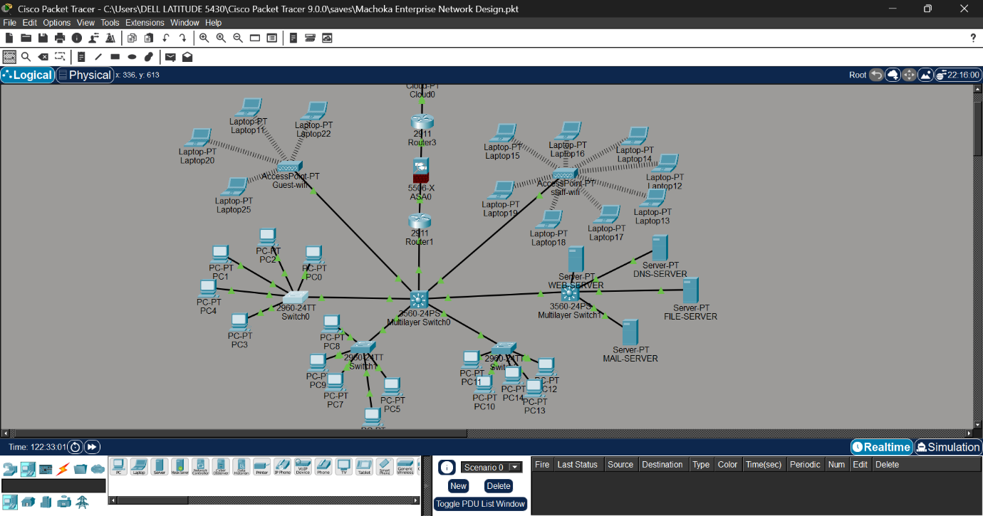
Figure 1.1

The enterprise network follows a hierarchical architecture consisting of the following components:
- Internet Cloud
- ISP Router
- Cisco ASA Firewall
- Core Router
- Cisco Catalyst 3560 Layer 3 Core Switch
- Cisco Catalyst 2960 Departmental Access Switches
- Wireless Access Points
- Enterprise Server
- Desktop Computers and Wireless Laptops
The Layer 3 Core Switch performs inter-VLAN routing and acts as the central distribution point for all VLANs. The access switches connect end-user devices within their respective departments, while the Cisco ASA Firewall secures traffic between the internal network and the Internet. Separate wireless networks are provided for staff and guests to enhance security and access control.

3.3 VLAN Design
The network is logically divided into Virtual Local Area Networks (VLANs) to improve security, reduce broadcast traffic, and simplify network management.
Table 2.1
Department | VLAN | Network Address | Default Gateway
Administration | 10 | 192.168.10.0/24 | 192.168.10.1
Finance | 20 | 192.168.20.0/24 | 192.168.20.1
IT | 30 | 192.168.30.0/24 | 192.168.30.1
Server Room | 40 | 192.168.40.0/24 | 192.168.40.1
Staff WiFi | 50 | 192.168.50.0/24 | 192.168.50.1
Guest WiFi | 60 | 192.168.60.0/24 | 192.168.60.1
Each department operates within its own VLAN, ensuring that broadcast traffic is limited to the relevant department while improving overall network security.

3.4 IP Addressing Scheme
A private Class C addressing scheme was used throughout the network. Each VLAN was allocated its own subnet with a dedicated default gateway configured on the Layer 3 switch.
The use of separate IP subnets simplifies network administration, improves routing efficiency, and supports future network expansion.

3.5 Network Security Design
Several security technologies were implemented to protect the enterprise network.
These include:
- VLAN Segmentation
- Secure Shell (SSH)
- Access Control Lists (ACLs)
- Port Security
- DHCP Snooping
- Cisco ASA Firewall
- Separate Staff and Guest Wireless Networks
These technologies provide layered security by controlling user access, protecting against unauthorized devices, preventing rogue DHCP servers, and filtering traffic entering and leaving the enterprise network.

3.6 Network Implementation
The network was implemented using Cisco Packet Tracer through the following stages:
- Designing the physical topology.
- Configuring VLANs on the Layer 3 switch.
- Configuring trunk links between switches.
- Configuring inter-VLAN routing.
- Configuring DHCP pools.
- Configuring wireless networks.
- Configuring SSH.
- Applying Access Control Lists.
- Configuring Port Security.
- Configuring DHCP Snooping.
- Configuring the Cisco ASA Firewall.
- Testing connectivity and security.

3.7 Testing and Verification
After configuration, several tests were performed to verify that the network functioned correctly.
The tests included:
- Successful DHCP address assignment
- Communication between authorized VLANs
- Restricted communication according to ACL rules
- Successful SSH remote login
- Verification of Port Security
- Verification of DHCP Snooping
- Internet connectivity through the ASA Firewall
- Wireless connectivity for Staff and Guest users
All tests confirmed that the network operated as expected and met the project requirements.

3.8 Chapter Summary
This chapter presented the design and implementation of the secure enterprise network. It described the network topology, VLAN design, IP addressing scheme, security architecture, implementation process, and testing procedures. The resulting network provides secure communication, efficient traffic management, and scalable infrastructure suitable for a modern enterprise environment.

CHAPTER FOUR

4.0 IMPLEMENTATION, CONFIGURATION AND TESTING
This chapter contains the configuration steps, CLI commands, screenshots from Cisco Packet Tracer, and verification results.

4.1 VLAN Configuration
The first step in the implementation was the creation of VLANs on the Cisco Catalyst 3560 Layer 3 switch. Each VLAN represents a separate department within the enterprise network, reducing broadcast traffic and improving network security.
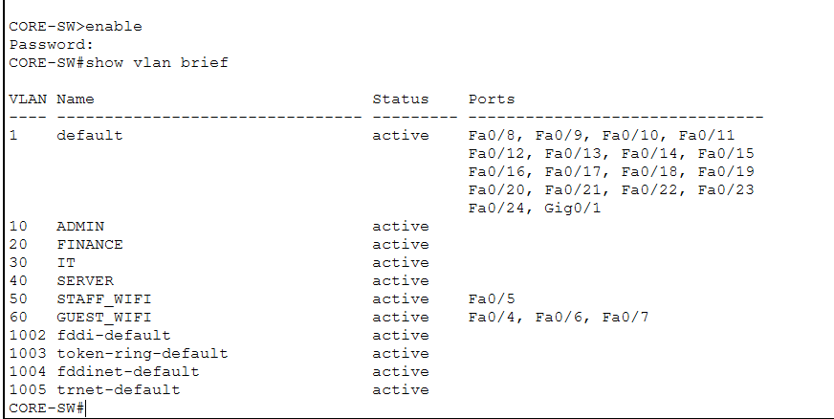
Figure 2.1
Figure 4.1: VLAN Configuration on the Core Switch
Figure 4.1 shows the successful creation of VLANs 10, 20, 30, 40, 50, and 60. Each VLAN corresponds to a specific department within the organization. The output of the show vlan brief command confirms that the VLANs were created successfully and assigned the correct names.

4.2 Trunk Configuration
After creating the VLANs, trunk links were configured between the Layer 3 switch and the access switches. Trunking allows multiple VLANs to pass through a single physical connection.
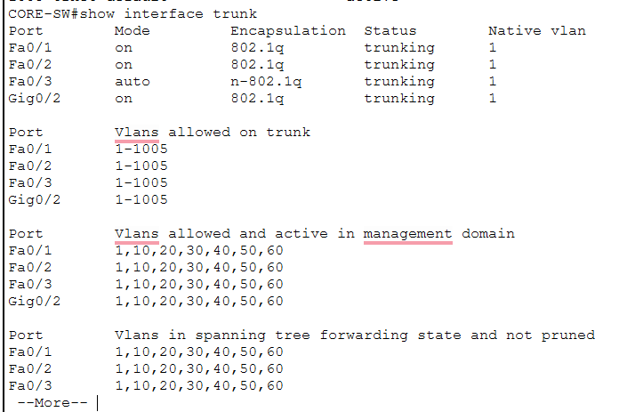
Figure 3.1

Figure 4.2: Trunk Port Verification
Explanation:
The output confirms that the trunk ports are operational and are carrying VLANs 10, 20, 30, 40, 50, and 60. This ensures communication between the core switch and departmental switches while maintaining VLAN separation.

4.3 Inter-VLAN Routing
Inter-VLAN routing was configured on the Layer 3 switch by assigning IP addresses to the Switch Virtual Interfaces (SVIs). This enables devices in different VLANs to communicate where permitted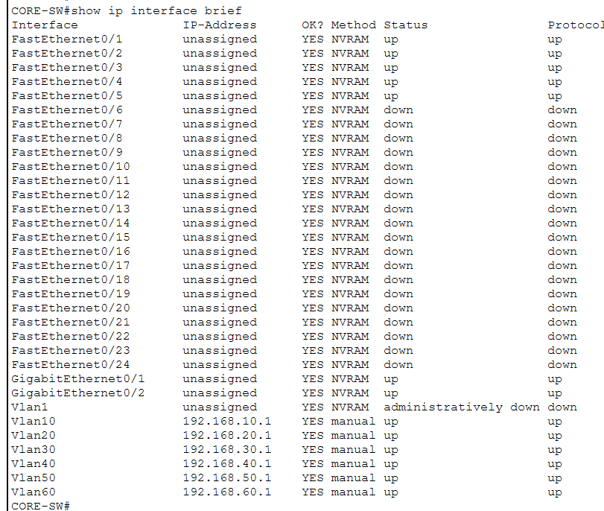
Figure 4.1:The figure shows that each VLAN has an active SVI configured with the correct gateway IP address. These interfaces act as the default gateways for devices within their respective VLANs.

4.4 DHCP Configuration
Dynamic Host Configuration Protocol (DHCP) was configured to automatically assign IP addresses, subnet masks, default gateways, and DNS information to devices within each VLAN. This eliminates the need for manual IP configuration and reduces the likelihood of addressing errors.
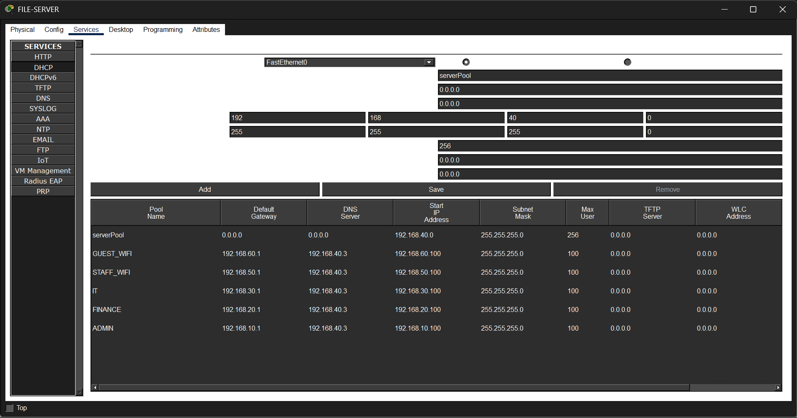
Figure 5.1: DHCP pool configuration on the Layer 3 switch.
The figure above shows the DHCP pools created for each VLAN. Each pool contains the appropriate network address, default gateway, and address range allocated to client devices.
.
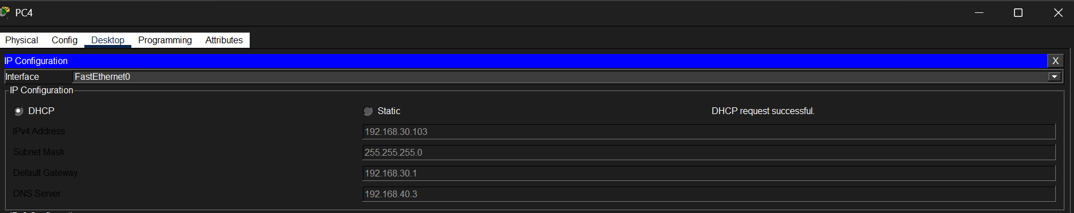
Figure 6.1Automatic IP address assignment on a client PC.
The screenshot confirms that the client computer successfully obtained an IP address, subnet mask, default gateway, and DNS information automatically from the DHCP server
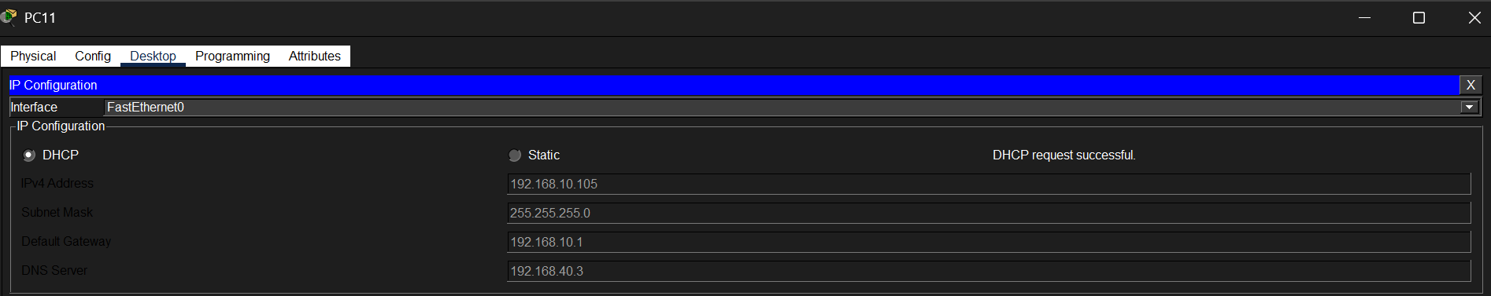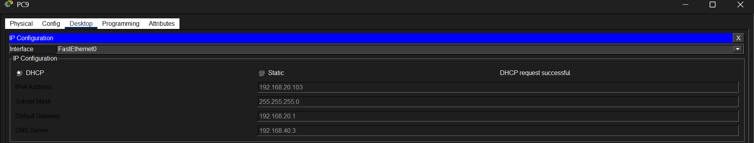
Figure 7.1: Verification of DHCP address allocation using the ipconfig command.
The ipconfig output verifies that the PC received the correct IP configuration from the DHCP server, confirming that DHCP services are functioning as expected.

4.5 Wireless Configuration
Separate wireless networks were created for employees and visitors. The Staff WiFi network provides secure access to internal resources, while the Guest WiFi network is isolated from the internal enterprise network.
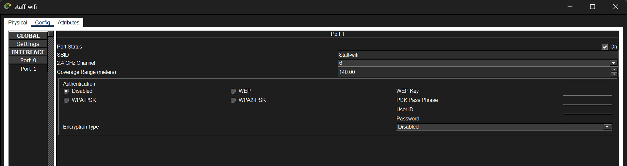
Figure 8.1: Staff wireless network (SSID).

The figure shows the configuration of the Staff WiFi SSID, which is intended for authorized employees.
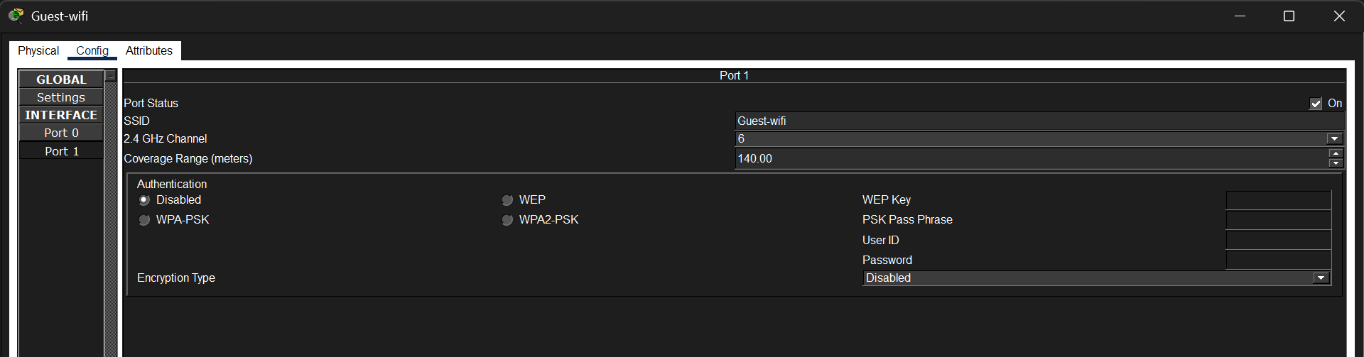
Figure 9.1: Guest wireless network (SSID).
The Guest WiFi network provides Internet access while restricting access to internal organizational resources.
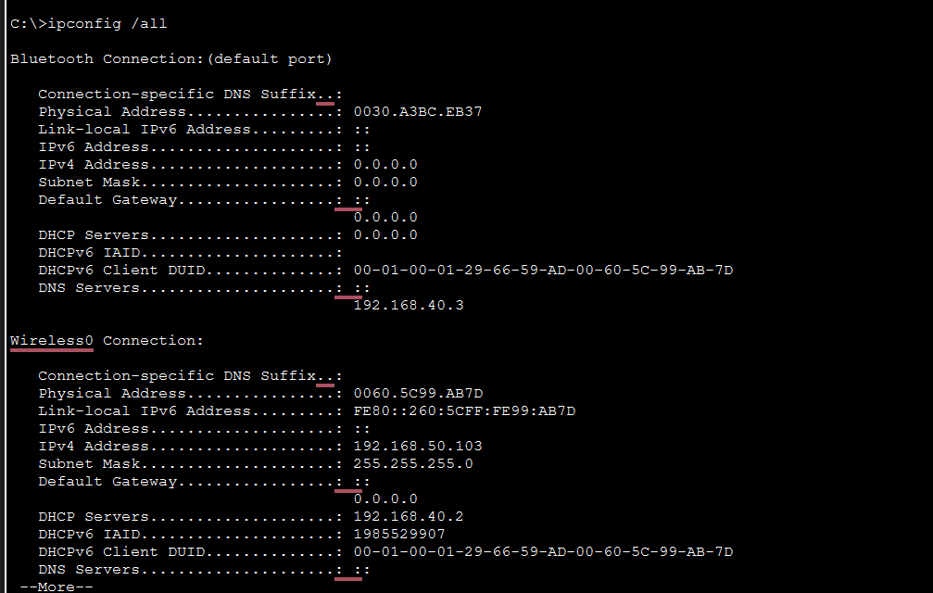
Figure 10.1: Wireless laptop successfully connected to the Staff WiFi network.
The successful connection indicates that the wireless network is operational and that clients can join the corresponding SSID.

4.6 SSH Configuration
Secure Shell (SSH) was configured to allow encrypted remote management of network devices. SSH protects administrator credentials and management traffic from interception.
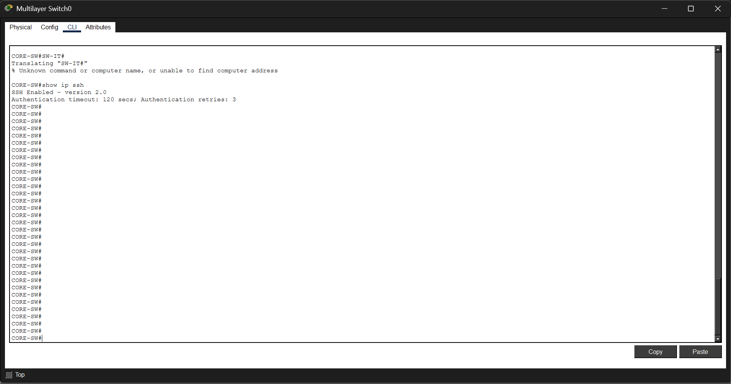
Figure 11.1: SSH configuration on the network device.
The configuration includes the hostname, domain name, RSA key generation, local user account, and VTY line configuration required for SSH access.
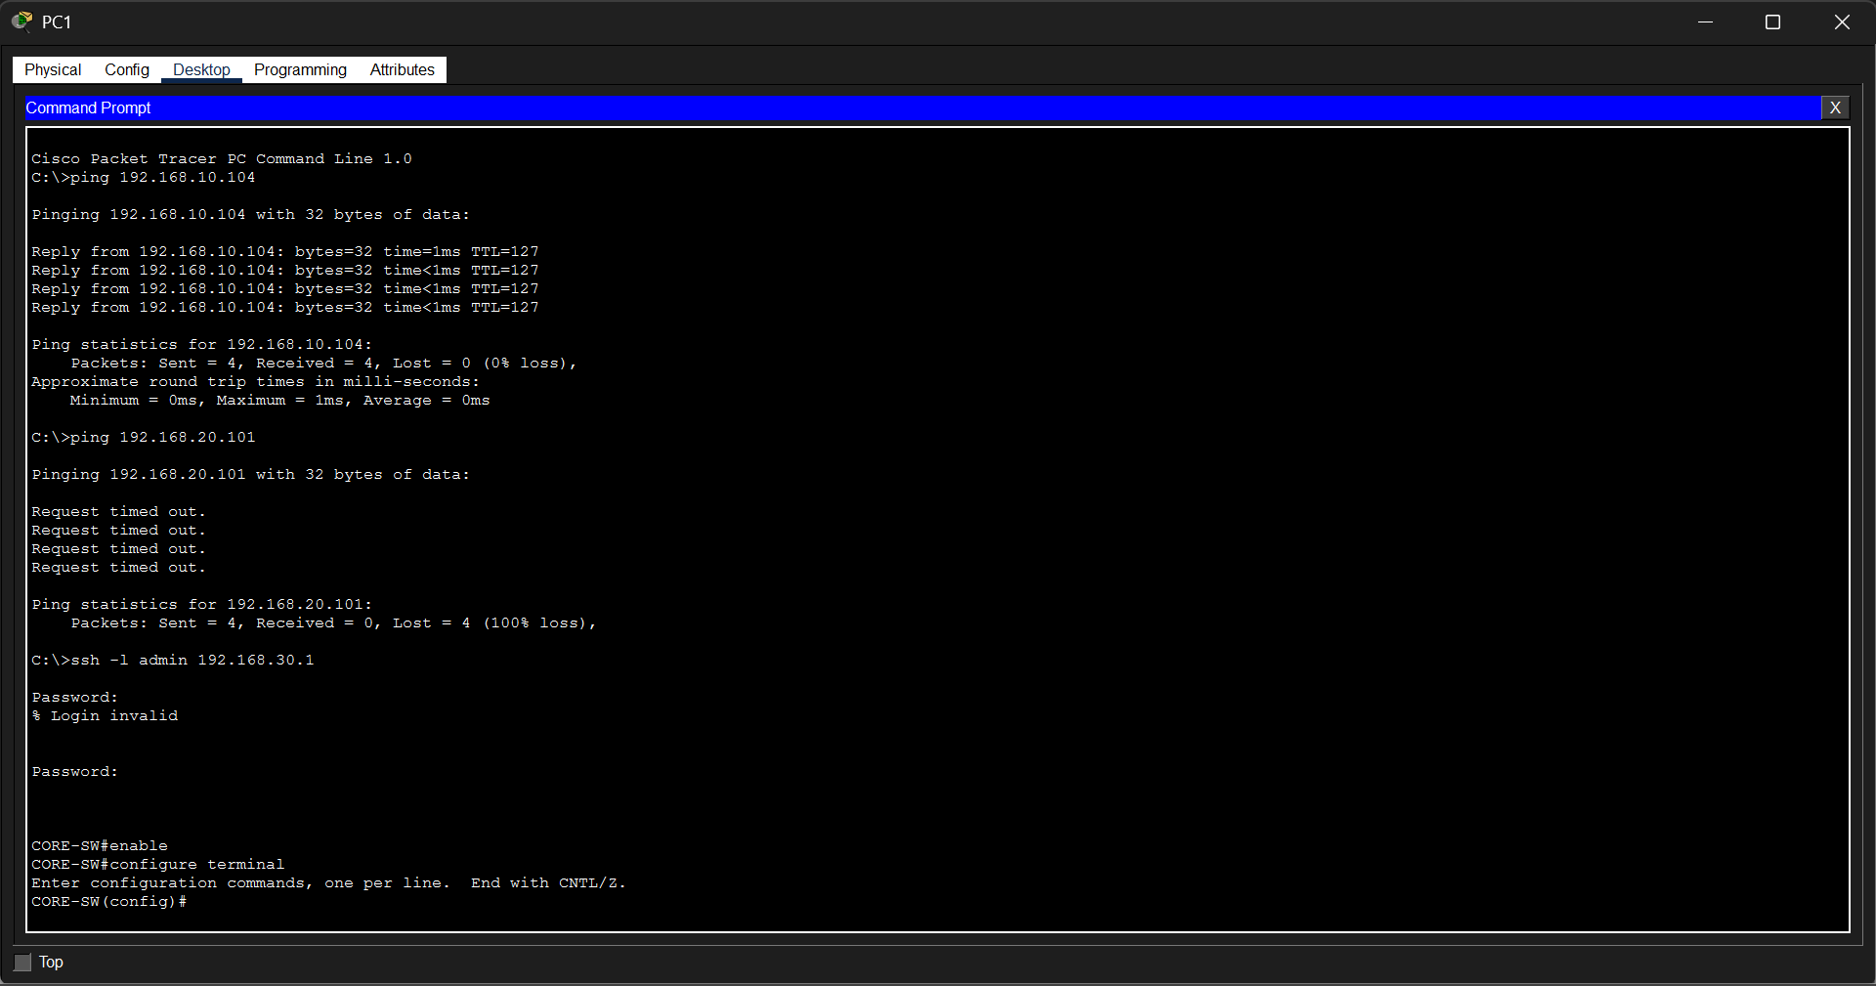
Figure 12.1: Successful SSH login from a client PC.
The successful login confirms that encrypted remote management has been configured correctly.
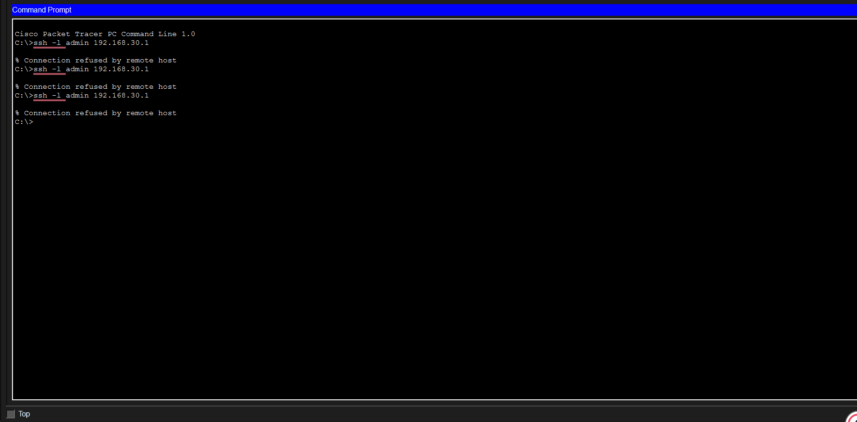
Figure 13.1:Denied ssh access

4.7 Access Control Lists (ACLs)

4.8 Port Security
Access Control Lists (ACLs) were implemented to control communication between VLANs based on organizational security requirements.
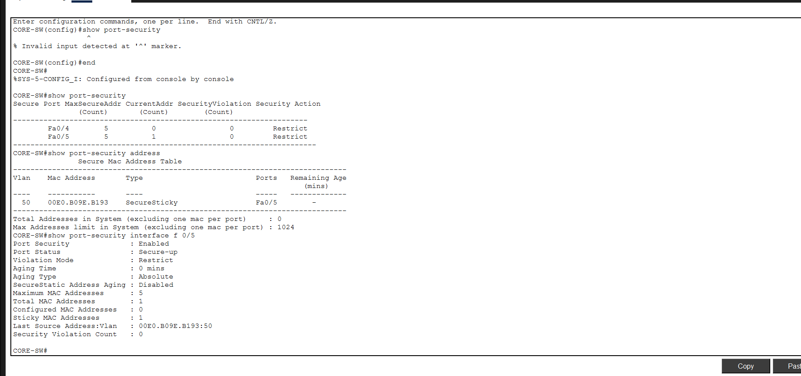
Figure 14.1: Extended ACL configuration.
The figure shows the configured ACL entries used to permit or deny communication between selected VLANs.
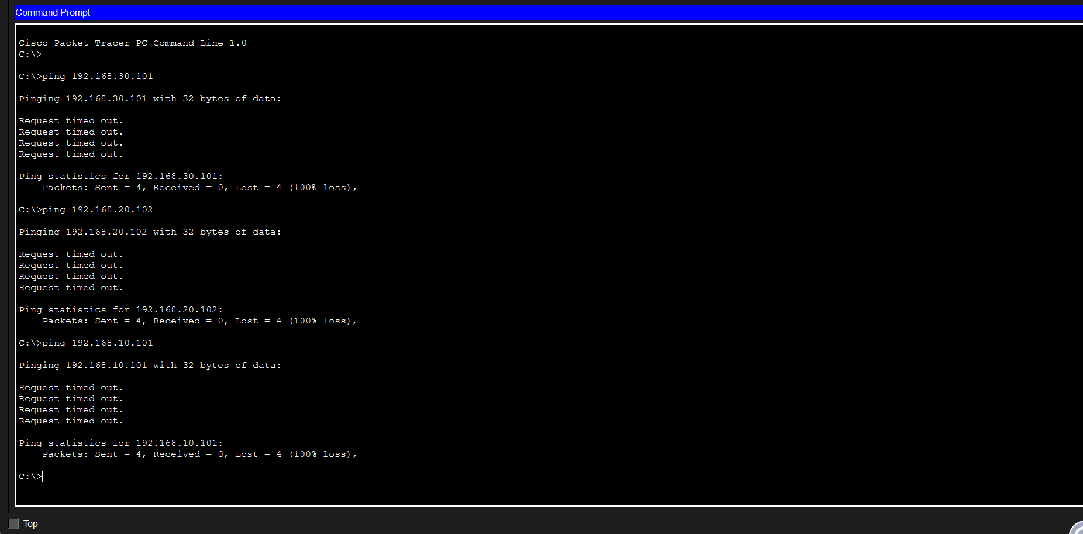
Figure 15.1: ACL blocking unauthorized communication.
The failed ping demonstrates that the ACL correctly prevents unauthorized communication between restricted VLANs.
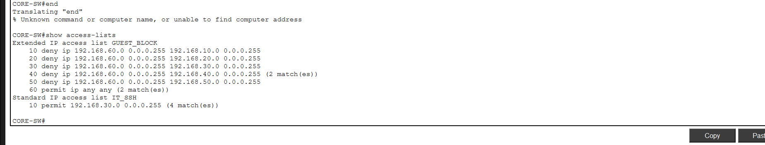
Figure 16.1: ACL verification.
The command output confirms that the configured ACLs are active and processing traffic.

4.9 DHCP Snooping
DHCP Snooping was configured to protect the network against rogue DHCP servers.
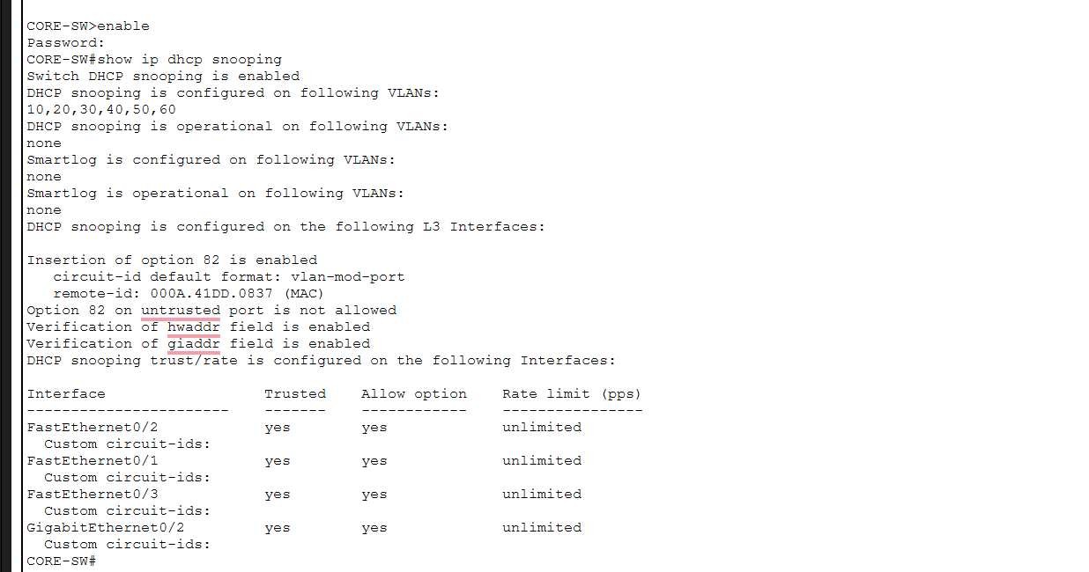
Figure 17.1: DHCP Snooping configuration.
Shows DHCP Snooping enabled on VLANs 10, 20, 30, 40, 50, and 60. The interfaces connected to trusted network devices were configured as trusted, allowing DHCP messages from legitimate DHCP servers while preventing unauthorized DHCP responses from untrusted ports.
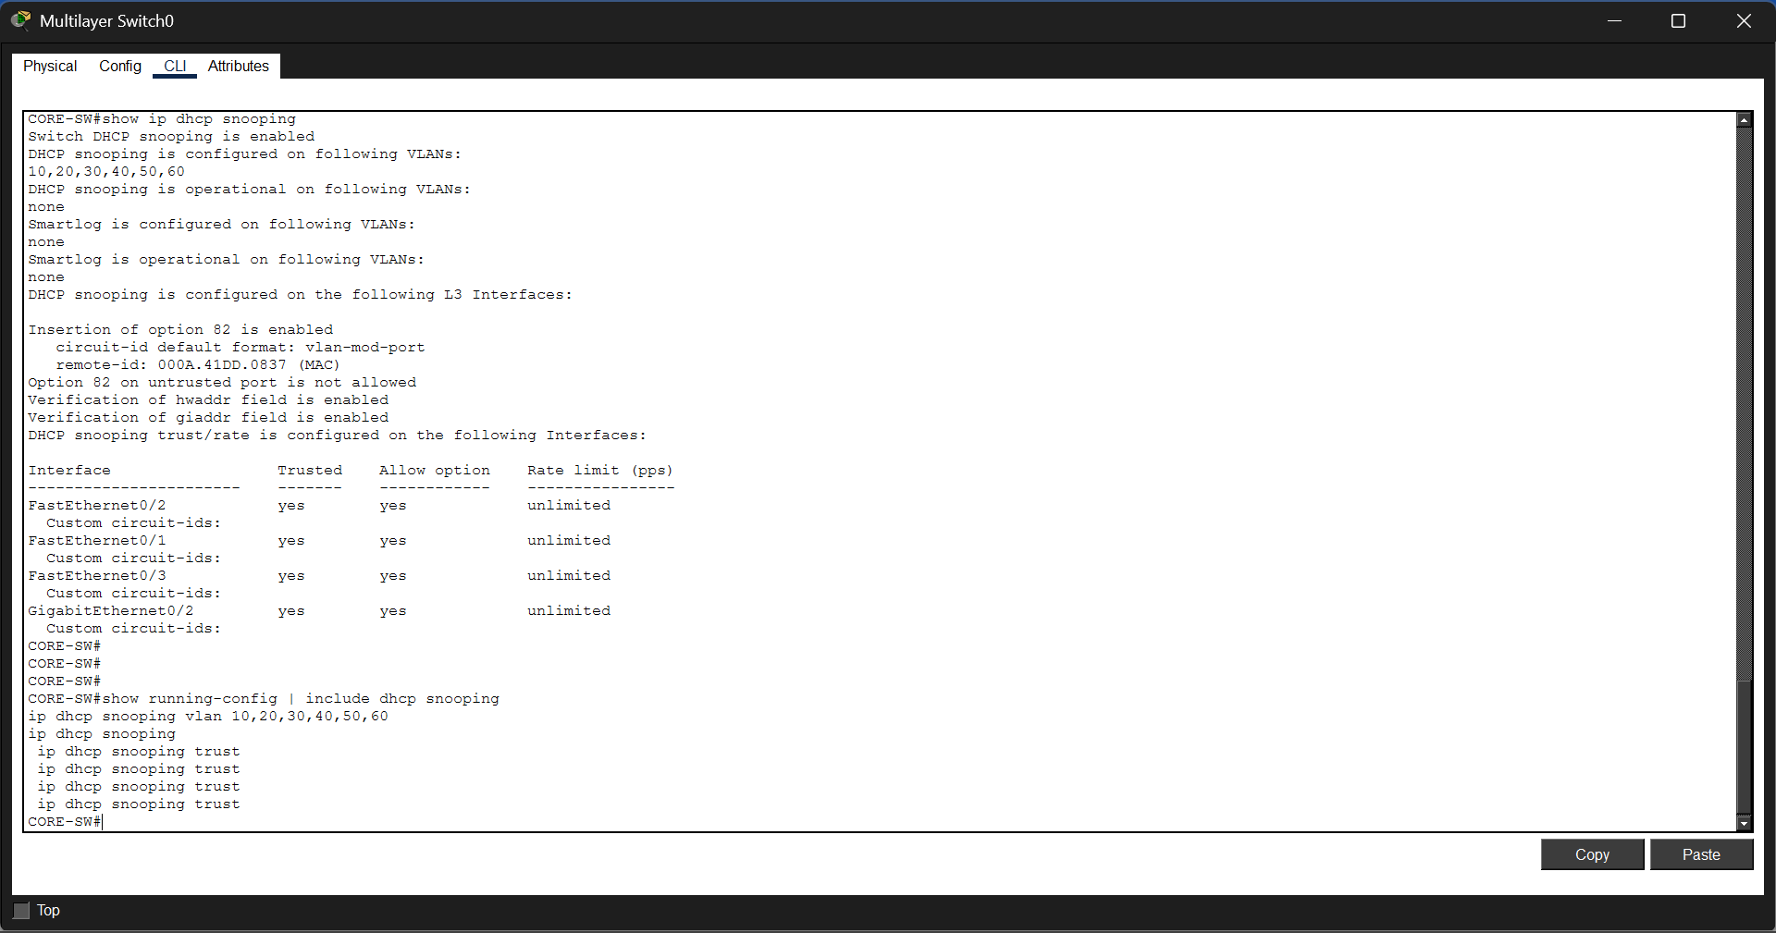
Figure 18.1: DHCP Snooping verification.
shows the output of the show ip dhcp snooping command, confirming that DHCP Snooping is enabled and operational on the required VLANs. The output also identifies the trusted interfaces, verifying that the network is protected against rogue DHCP servers.

4.10 Cisco ASA Firewall
The Cisco ASA Firewall was configured to secure communication between the enterprise network and the Internet.
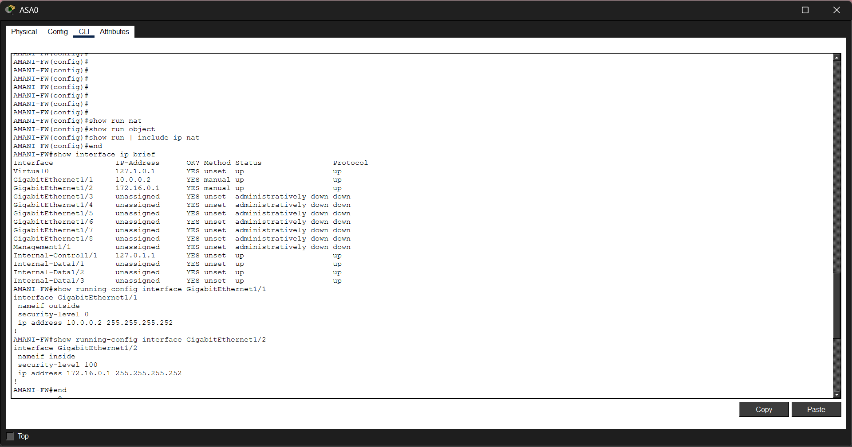
Figure 19.1: ASA firewall interface configuration.
The configuration enables internal users to access external networks securely.
The successful connectivity verifies that the firewall is forwarding authorized traffic while protecting the enterprise network.

.

CHAPTER FIVE

5.0 CONCLUSION, PROJECT PLAN, AND RECOMMENDATIONS

5.1 Introduction
This chapter presents a summary of the project, including the conclusions drawn from its implementation, the project schedule, the estimated project budget, recommendations, and future work.

5.2 Project Summary
The project successfully designed and implemented a secure enterprise network using Cisco Packet Tracer. The network was logically segmented into VLANs for the Administration, Finance, IT, Server Room, Staff Wireless, and Guest Wireless departments. Inter-VLAN routing was configured using a Layer 3 switch, while centralized DHCP services provided automatic IP address allocation.
To enhance network security, Secure Shell (SSH), Access Control Lists (ACLs), Port Security, DHCP Snooping, and a Cisco ASA Firewall were implemented. Testing confirmed that the network provided secure communication, controlled access between departments, reliable connectivity, and efficient network management.

5.3 Conclusion
The project achieved its objective of designing and implementing a secure enterprise network using Cisco Packet Tracer. The implementation demonstrated how VLAN segmentation, inter-VLAN routing, and multiple security mechanisms can improve network performance, simplify administration, and protect organizational resources. The completed network provides a scalable and secure infrastructure suitable for a modern enterprise environment.

5.4 Project Schedule
The project was completed according to the following implementation plan.

Table 3.1
Activity | Duration
Requirements Analysis | 2 Days
Network Design | 3 Days
VLAN Configuration | 2 Days
Inter-VLAN Routing | 1 Day
DHCP Configuration | 1 Day
Wireless Network Configuration | 1 Day
SSH and ACL Configuration | 2 Days
Port Security and DHCP Snooping | 2 Days
ASA Firewall Configuration | 2 Days
Testing and Troubleshooting | 3 Days
Documentation and Report Writing | 5 Days
Total Project Duration | 24 Days

5.5 Estimated Project Budget
The following table shows the estimated resources required to complete the project.
Table 4.1
Item | Estimated Cost (KES)
Laptop | 80,000
Internet/Data Bundles | 3,000
Electricity | 2,000
Printing and Binding | 2,500
Stationery | 1,000
Miscellaneous Expenses | 1,500
Total Estimated Cost | 90,000

5.6 Recommendations
The following recommendations are proposed for future improvements:
- Implement Virtual Private Network (VPN) services for secure remote access.
- Deploy network monitoring and logging tools.
- Introduce redundant network links to improve availability.
- Upgrade the network to support IPv6.
- Conduct regular security audits and software updates.

5.7 Future Work
Future work may include implementing dynamic routing protocols such as OSPF, integrating cloud-based services, deploying Intrusion Detection and Prevention Systems (IDS/IPS), and implementing centralized authentication using RADIUS or TACACS+.

5.8 Chapter Summary
This chapter summarizes the project and concludes that the proposed enterprise network successfully met its objectives. The project schedule and estimated budget were presented, together with recommendations and future enhancements that can further improve the security, scalability, and reliability of the enterprise network.

References (APA 7th Edition)
- Cisco Networking Academy. (2024). Introduction to Networks (Version 7.0) Companion Guide. Cisco Press.
- Cisco Systems. (2024). Cisco Packet Tracer User Guide. https://www.netacad.com
- Odom, W. (2020). CCNA 200-301 Official Cert Guide, Volume 1. Cisco Press.
- Odom, W. (2020). CCNA 200-301 Official Cert Guide, Volume 2. Cisco Press.
- Stallings, W. (2021). Network Security Essentials: Applications and Standards (7th ed.). Pearson.
- Forouzan, B. A. (2017). Data Communications and Networking (5th ed.). McGraw-Hill Education.

APPENDICES

Appendix A: Complete Enterprise Network Topology
Insert a full screenshot of your Cisco Packet Tracer topology.
Appendix B: IP Addressing Scheme
VLAN | Department | Network | Gateway
10 | Administration | 192.168.10.0/24 | 192.168.10.1
20 | Finance | 192.168.20.0/24 | 192.168.20.1
30 | IT | 192.168.30.0/24 | 192.168.30.1
40 | Server | 192.168.40.0/24 | 192.168.40.1
50 | Staff WiFi | 192.168.50.0/24 | 192.168.50.1
60 | Guest WiFi | 192.168.60.0/24 | 192.168.60.1

